Lab 2: Deadlock Avoidance Using Banker's Algorithm

Theory
A deadlock is a situation in an operating system where a group of processes becomes permanently blocked because each process is waiting for a resource that is held by another process in the group. As a result, none of the processes can continue execution, causing the system to halt indefinitely unless corrective measures are taken.
Necessary Conditions for Deadlock
A deadlock can occur only if the following four conditions hold simultaneously:
- Mutual Exclusion: At least one resource is non-shareable and can be used by only one process at a time.
- Hold and Wait: A process holding one or more resources requests additional resources that are currently allocated to other processes.
- No Preemption: Resources cannot be forcibly taken away from a process; they must be released voluntarily.
- Circular Wait: A circular chain of processes exists where each process is waiting for a resource held by the next process in the chain.
Methods of Handling Deadlocks
Operating systems use one or more of the following strategies:
- Deadlock Prevention: Ensures that at least one of the necessary conditions for deadlock cannot occur.
- Deadlock Avoidance: Allocates resources only if doing so keeps the system in a safe state.
- Deadlock Detection: Allows deadlocks to occur and periodically checks for their presence.
- Deadlock Recovery: Terminates processes or preempts resources to recover from a detected deadlock.

Banker's Algorithm
The Banker's Algorithm, proposed by Edsger W. Dijkstra, is a deadlock avoidance algorithm used to determine whether granting a resource request will keep the system in a safe state. The algorithm checks the availability of resources before allocation to ensure that all processes can complete without causing a deadlock.
Data Structures Used
The algorithm maintains the following data structures:
- Allocation Matrix: Number of resources of each type currently allocated to each process.
- Maximum Matrix: Maximum number of resources of each type that each process may require.
- Available Vector: Number of available instances of each resource type.
- Need Matrix: Remaining resources required by each process, calculated as:
Need = Maximum − Allocation

Working of the Algorithm
The Banker's Algorithm performs the following steps:
- Calculate the Need Matrix for all processes.
- Compare the Need of each unfinished process with the Available resources.
- If a process's needs can be satisfied, assume it completes execution and releases its allocated resources.
- Update the Available resources and repeat the process for the remaining processes.
- If all processes can finish successfully, the system is in a safe state and a safe sequence exists.
- If no process can proceed at any stage, the system is in an unsafe state, and granting the resource request may eventually lead to a deadlock.

Flow Chart
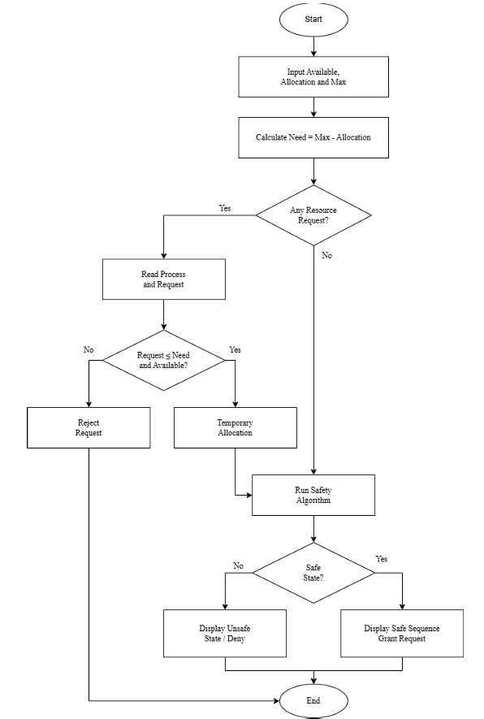

Advantages
- Prevents deadlocks before they occur.
- Ensures safe allocation of resources.
- Determines whether a safe execution sequence exists.
- Suitable for systems where the maximum resource requirement of each process is known in advance.
Limitation
- Requires prior knowledge of the maximum resource requirements of every process.
- May reduce resource utilization because some requests are denied to maintain system safety.
- Becomes computationally expensive as the number of processes and resources increases.

Source Code:
allocation = [
[0, 1, 0],
[2, 0, 0],
[3, 0, 2],
[2, 1, 1],
[0, 0, 2],
]

maximum = [
[7, 5, 3],
[3, 2, 2],
[9, 0, 2],
[2, 2, 2],
[4, 3, 3],
]

available = [3, 3, 2]

def bankers_algorithm(allocation, maximum, available):
process_count = len(allocation)
resource_count = len(available)

need = [
[maximum[i][j] - allocation[i][j] for j in range(resource_count)]
for i in range(process_count)
]

work = available.copy()
finished = [False] * process_count
safe_sequence = []

while len(safe_sequence) < process_count:
found_process = False

for i in range(process_count):
if not finished[i] and all(
need[i][j] <= work[j] for j in range(resource_count)
):
for j in range(resource_count):
work[j] += allocation[i][j]

finished[i] = True
safe_sequence.append(f"P{i}")
found_process = True

if not found_process:
return False, []

return True, safe_sequence

is_safe, sequence = bankers_algorithm(allocation, maximum, available)

if is_safe:
print("System is in a safe state.")
print("Safe sequence:", " -> ".join(sequence))
else:
print("System is not in a safe state.")

Output
Process | Allocation (A, B, C) | Maximum (A, B, C) | Available (A, B, C)
P0 | [0, 1, 0] | [7, 5, 3] | [3, 3, 2]
P1 | [2, 0, 0] | [3, 2, 2]
P2 | [3, 0, 2] | [9, 0, 2]
P3 | [2, 1, 1] | [2, 2, 2]
P4 | [0, 0, 2] | [4, 3, 3]
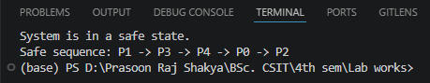
When available = [0, 0, 0]:
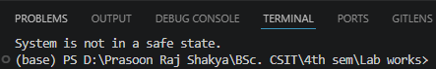

Conclusion
In this lab, Banker's Algorithm was implemented to avoid deadlock by checking whether the system remains in a safe state before allocating resources. Using the allocation, maximum demand, and available resource values, the program calculated a safe sequence of processes. This demonstrates how proper resource allocation can prevent deadlocks and ensure that all processes complete successfully.

